SSAA State Titles
Field Rifle to be held on 6th and 7th March 2021, at Moonta, S A
117 Arthurton Road, East Moonta SA
Enquiries; Doug Warmington 8825 2039 or 0409496 729

Saturday 6th March 3p Rimfire start time morning 10.00am
Field Rifle, Centrfire start time afternoon t.b.a.

Sunday 7th March Field Rifle Rimfire start time morning 10.00am
3P Centrfire start time afternoon t.b.a.

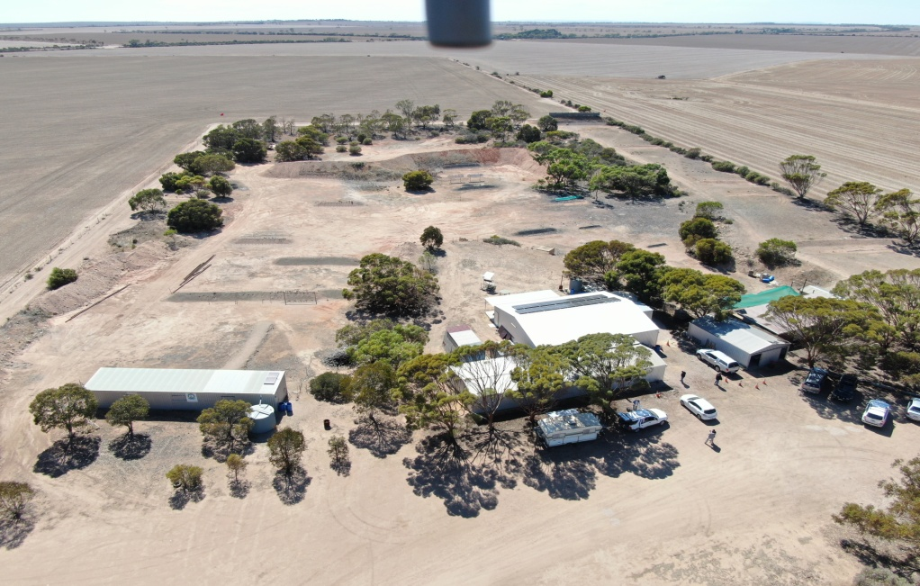
Please note, due to Covid, canteen may not be operating, please ring before hand to check if opening for the event Doug Warmington 8825 2039
other enquiries Paul Robinson State Discipline Chairperson
Field rifle, 10m Air, NRA 3p Air
email; robinsonseven@bigpond.com
mob; 0422 165 372 home ; 82524108

