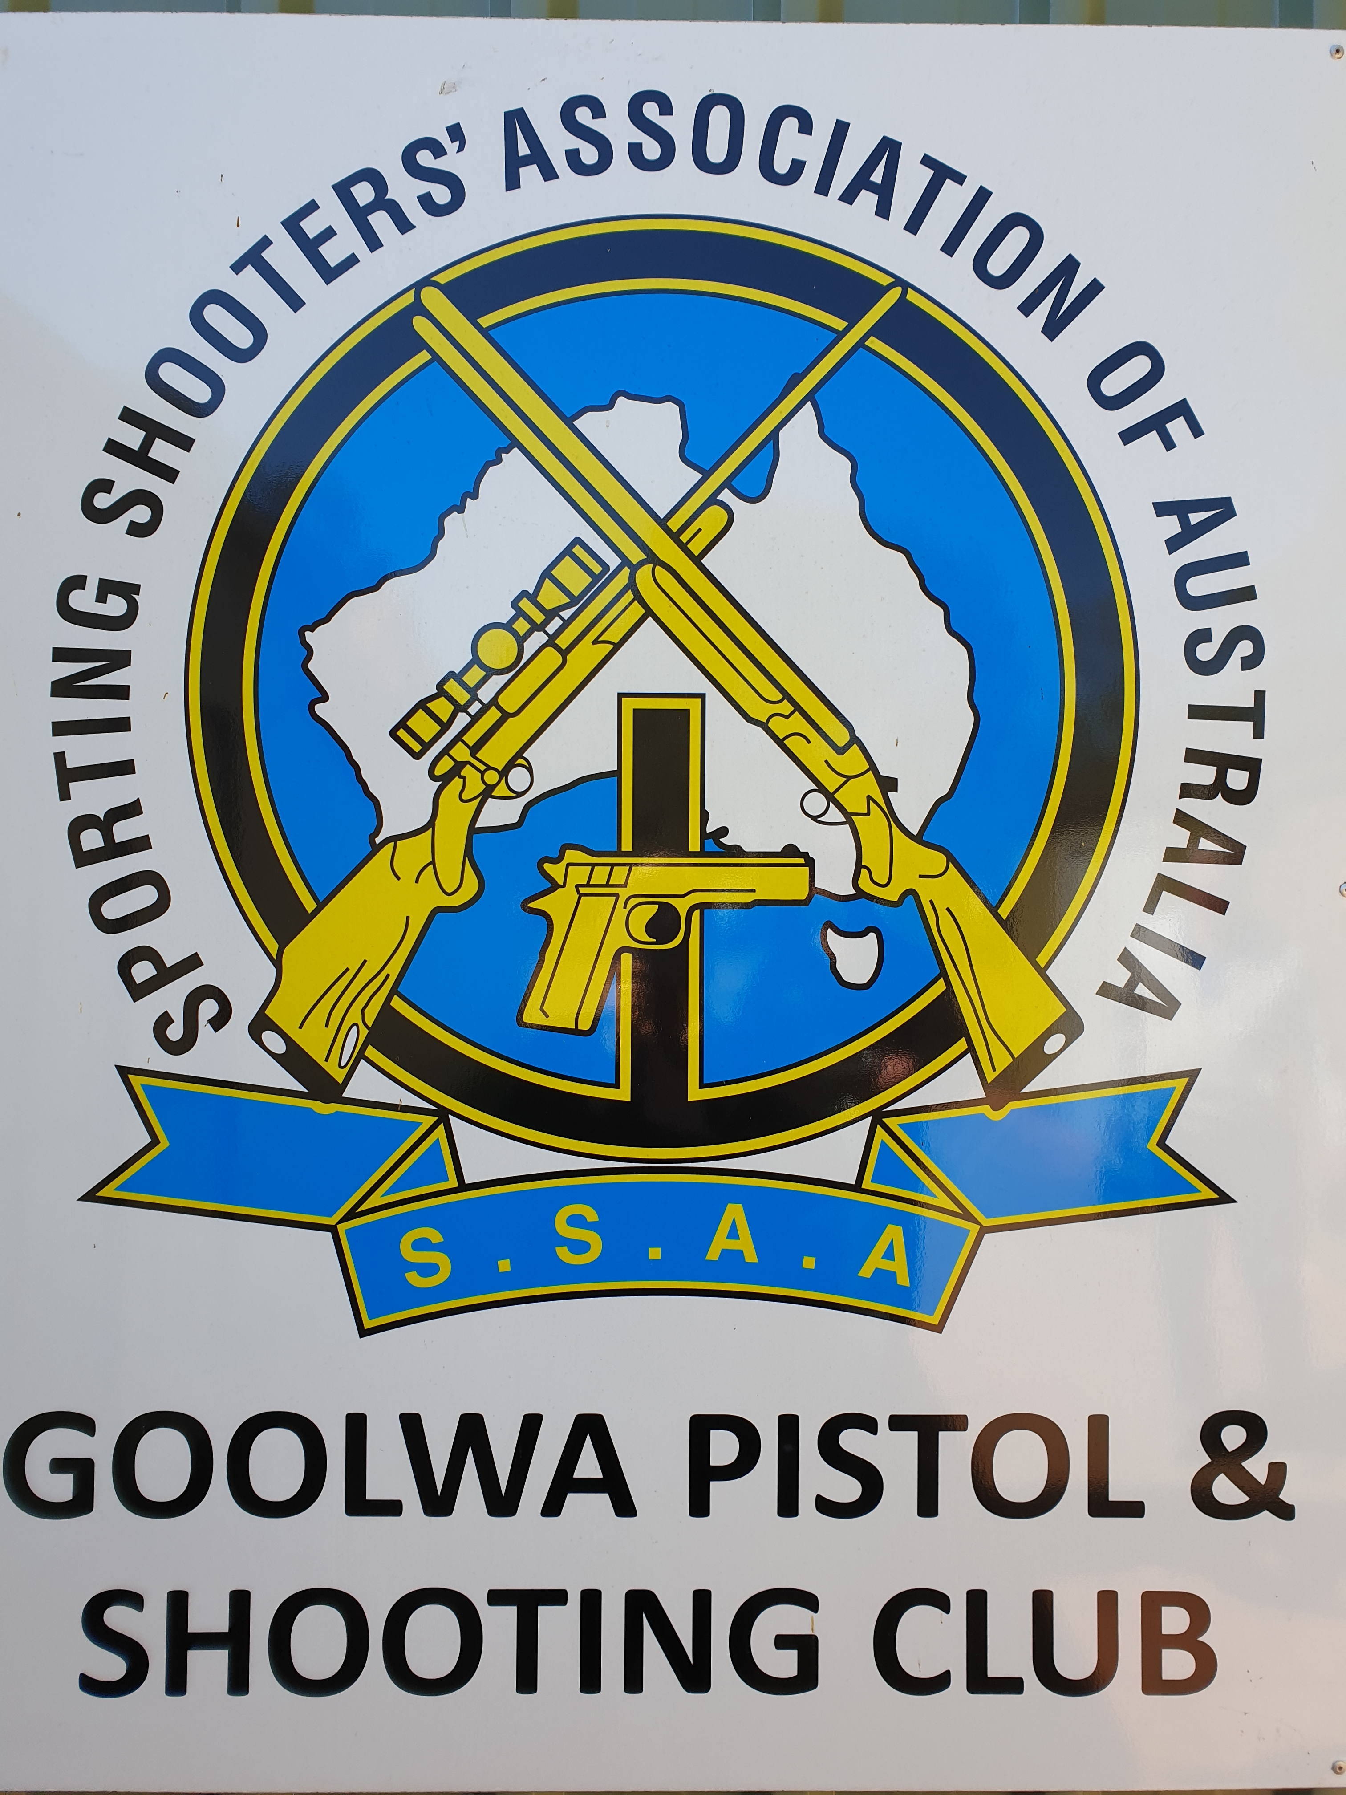
NOMINATION FORM
2024 SSAA SA MUZZLE LOADING PISTOL STATE CHAMPIONSHIPS

Hosted by SSAA Goolwa Branch
59 Peel Road, Currency Creek SA 5214

Saturday, November 2nd 2024

Name: ………………………………………………………………………………………………………………………………………………SSAA #: ……………….….

Address: …................................................................................................................................................................................

Branch: …………………………………………………………………………………………………….……… Phone No.: …………………………………………….

E-mail: ………………………………………………………………………………..…………………………………….. Left/Right Handed......................

SSAA SA Muzzle Loading State Championships (Pistol) NOMINATION FEES PER PERSON
Nominations to be lodged with – SSAA Goolwa, PO Box 80, Port Elliot 5212
Or Email: secretary.gpasc@gmail.com
SSAA Goolwa has EFTPOS facilities available Or Pay cash on the day
Program may vary due to match scheduling, weather or other unforeseen circumstances.
Shooters will need to be aware of squadding times for each event on the day. BBQ Dinner Saturday Night.
$

Total Number of Events Nominated in Pistol @ $5 each (Max $20)

$
Number of people attending the BBQ Dinner @ $10 each for full BBQ or $5 for simple
BBQ (Sausage & bread)
$
Total

Sharing of firearms: With whom and events. Please inform ......................................................

SSAA SA STATE CHAMPIONSHIPS NOMINATION FORM
Saturday 2nd November 2024 Nominations .

Appx Start | EVENT | Distance | Event | Class |  | Calibre
10:30am | 1 | 25m | Precision Revolver | Class 1
11:15am | 2 | 25m | Timed Fire Revolver | Class 1
12:00pm |  |  | Lunch
13:00pm | 3 | 25m | Precision Pistol | Class 2
13:45pm | 4 | 25m | Precision revolver/pistol | Class 3
14:30pm | 5 | 25m | Precision Pistol s/bore | Firelock
15:15pm | 6 | 50m | Precision revolver/pistol | Class 3
 |  |  | BBQ

